Lab 1: Creating Your First Dashboard

© 2024 Amazon Web Services, Inc. or its affiliates. All rights reserved. This work may not be reproduced or redistributed, in whole or in part, without prior written permission from Amazon Web Services, Inc. Commercial copying, lending, or selling is prohibited. All trademarks are the property of their owners.

Note: Do not include any personal, identifying, or confidential information into the lab environment. Information entered may be visible to others.

Corrections, feedback, or other questions? Contact us at [*AWS Training and Certification*](https://support.aws.amazon.com/#/contacts/aws-training).

**Lab overview**

You are a new data analyst at AnyCompany Software. The company has asked you to create dashboards on Amazon QuickSight to prepare for the upcoming corporate board meeting. AnyCompany Software has used various tools in the past to visualize their data, but the company wants to migrate to Amazon QuickSight.

Why QuickSight? First, the company wants to tie in with data stored in Excel files, Amazon Redshift, Amazon DynamoDB, and Amazon Simple Storage Service (Amazon S3). Second, the company wants to develop dashboards on a serverless, low-latency solution and move to a cost-effective service that works with their growing cloud infrastructure. You are investigating how QuickSight can be used to visualize data and how reports can be built to share with the board of AnyCompany Software.

In this lab, you use QuickSight to load in your company’s sales data saved in an Excel file. You then create visualizations, forecast future sales, drill down into the data, add filters, and share reports.

OBJECTIVES

By the end of this lab, you should be able to do the following:

* Load a dataset into Amazon QuickSight.
* Create QuickSight dashboards.
* Customize QuickSight dashboards to visualize data and extract business insights.
* Configure appropriate visualization types to identify trends in the data.

DURATION

This lab requires approximately *35* minutes to complete.

ICON KEY

Various icons are used throughout this lab to call attention to different types of instructions and notes. The following list explains the purpose for each icon:

* **Expected output:** A sample output that you can use to verify the output of a command or edited file.
* **Note:** A hint, tip, or important guidance.
* **Learn more:** Where to find more information.
* **Consider:** A moment to pause to consider how you might apply a concept in your own environment or to initiate a conversation about the topic at hand.
* **Hint:** A hint to a question or challenge.
* **Answer:** An answer to a question or challenge.
* **Task complete:** A conclusion or summary point in the lab.

**Start lab**

1. To launch the lab, at the top of the page, choose Start lab.

**Caution:** You must wait for the provisioned AWS services to be ready before you can continue.

1. To open the lab, choose Open Console.

You are automatically signed in to the AWS Management Console in a new web browser tab.

**WARNING:** **Do not change the Region unless instructed.**

COMMON SIGN-IN ERRORS

**Error: You must first sign out**

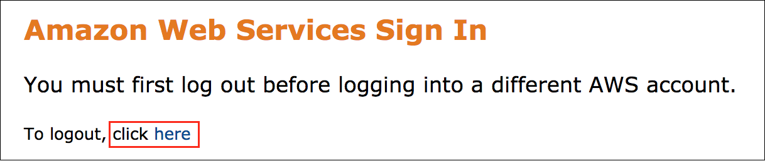

If you see the message, **You must first log out before logging into a different AWS account:**

* Choose the **click here** link.
* Close your **Amazon Web Services Sign In** web browser tab and return to your initial lab page.
* Choose Open Console again.

**Error: Choosing Start Lab has no effect**

In some cases, certain pop-up or script blocker web browser extensions might prevent the **Start Lab** button from working as intended. If you experience an issue starting the lab:

* Add the lab domain name to your pop-up or script blocker’s allow list or turn it off.
* Refresh the page and try again.

AWS SERVICES NOT USED IN THIS LAB

AWS service capabilities used in this lab are limited to what the lab requires. Expect errors when accessing other services or performing actions beyond those provided in this lab guide.

**Task 1: Create and explore the dataset**

As you move your current dashboard analytics to AWS, you should have a basic understanding of the features and user interface of Amazon QuickSight. You decide to load in the most recent processed sales data for AnyCompany Software to prepare for a quarterly business review with the board.

In this task, you load in a business intelligence engineer’s cleaned dataset from an Excel file. After loading it into QuickSight, you explore the data and prepare it for analysis.

TASK 1.1: CREATE YOUR DATASET

Download the data sent over from the business intelligence engineer and load it into QuickSight.

1. At the top of the **AWS Management Console**, in the search bar, search for and choose

.

1. Save the [SaaS-sales.csv](https://us-west-2-tcprod.s3.amazonaws.com/courses/ILT-DD-300-DAQSAU/v1.4.1.prod-74c9bead/lab-1/scripts/SaaS-Sales.csv) file to your local machine (you can usually right-click and choose “Save link as…” from your browser to do this).
2. In the left navigation pane, choose **Datasets**.
3. In the top right of the page, choose **New dataset**.
4. From the list of sources, choose **Upload a file**.
5. Choose the **SaaS-Sales.csv** file that you saved to your local machine and choose **Open**.
6. After the preview loads, choose **Next**.

**Learn more:** Your data has been loaded into SPICE, the robust in-memory engine that QuickSight uses. For more information about SPICE, see [Importing data into SPICE](https://docs.aws.amazon.com/quicksight/latest/user/spice.html) in the *Amazon QuickSight User Guide*.

1. Choose **Visualize**.
2. Verify that **Interactive sheet** is selected, and choose **CREATE**.

**Consider:** You are now in the QuickSight dashboard editor. Take a moment to explore the editor, organized into six key sections:

* The menu bar, located at the top of the QuickSight page
* The navigation pane, located directly under the menu bar of the QuickSight page



* The Fields list pane, located at the left of the QuickSight page

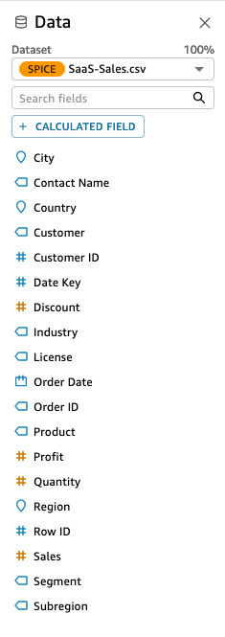

* The Visuals pane, located in the second column of the QuickSight page (only visible when you have selected a visualization from the Fields list on the sheet)

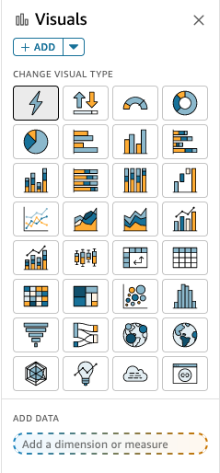

* The AutoGraph dashboard workspace, located in the third column of the QuickSight page

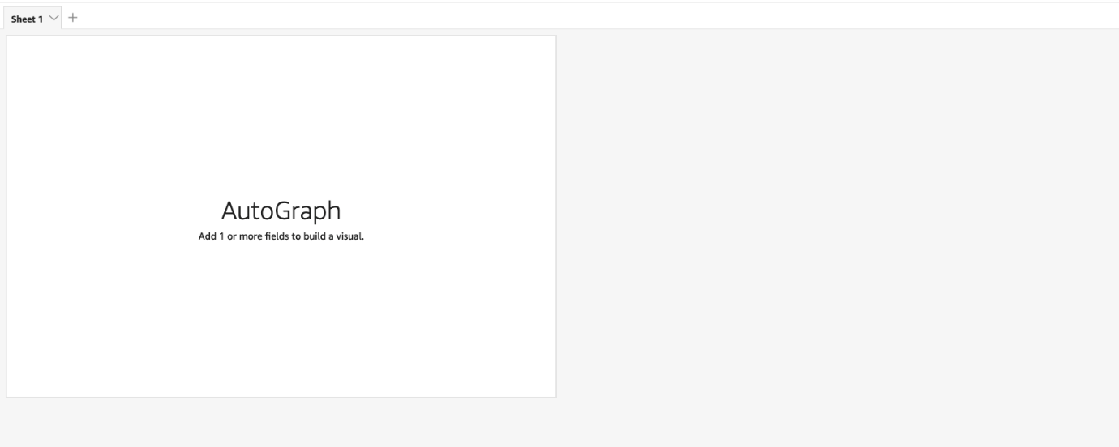

* The visualization menu, located in the dashboard workspace on each visualization

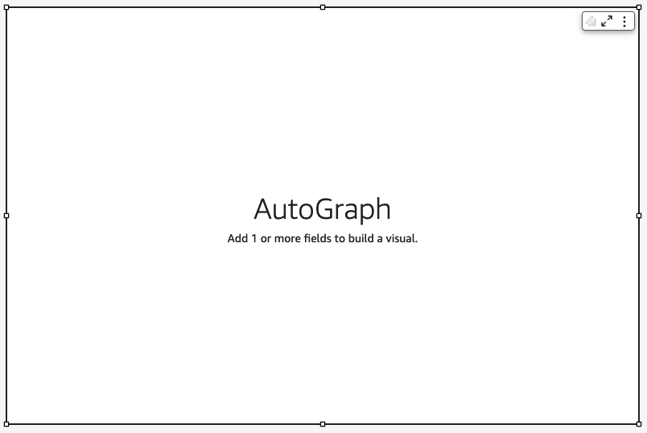

TASK 1.2: VIEW YOUR DATASET

Create your first visualization using sales data over time, and edit the time frame to a monthly view.

1. In the **Fields list** pane, choose **Sales** and then choose **Order Date**.

**Expected output:** A line graph appears with sales fluctuating between $0 and $28,000 a day. AutoGraph in QuickSight intuitively selects visualizations that work with the data fields you choose.

1. In the **Visuals** pane, locate **Order date** under the **X Axis**.
2. Next to **Order date**, choose the ellipsis icon.
3. Hover over **Aggregate: Day** and choose **Month** to change the aggregation to month.

**Expected output:** The graph changes from a daily view to a monthly view, smoothing out the trends and showing a more relevant picture of sales over time. QuickSight quickly and dynamically calculates the aggregation changes using SPICE, showing your monthly results in seconds.

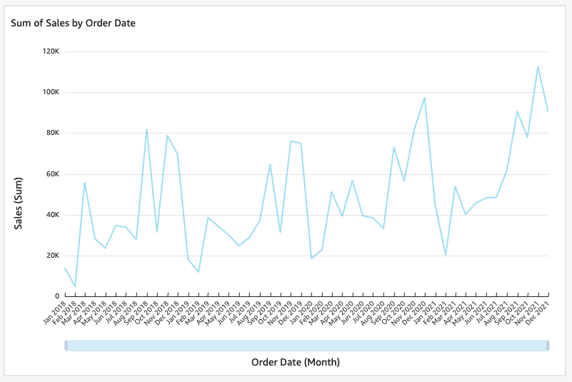

*Image description: The preceding image shows the line graph of sales over time*.

* **Task complete:** You have completed **Task 1** by creating and exploring a dataset in QuickSight. You created a dataset from an Excel file and visualized sales data over time using the AutoGraph feature of QuickSight.

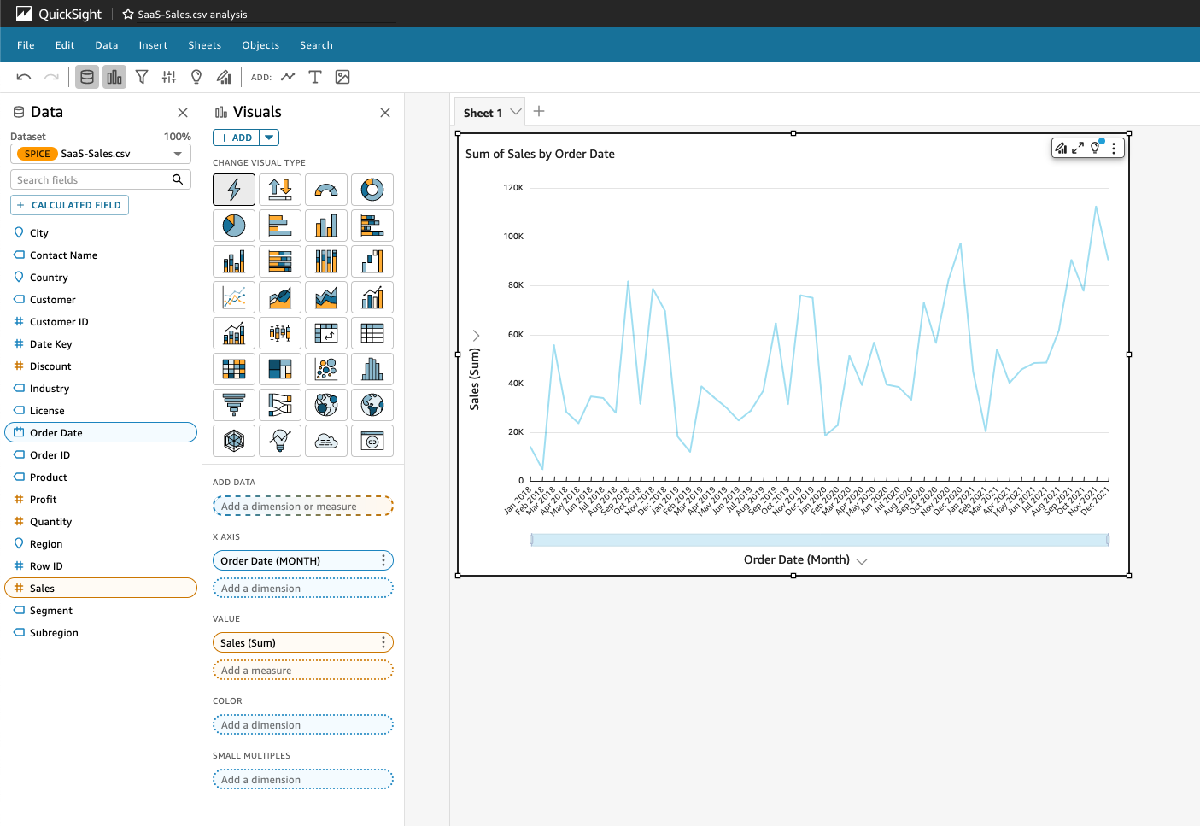

*Image description: The preceding image shows the analysis, complete with the line graph visual*.

**Task 2: Explore visual types**

Now that your dataset is loaded, you want to explore different visual types in QuickSight that help communicate your data effectively. You test the predictive modeling capabilities of QuickSight and explore text-based insights, centralizing your analysis in one place.

In this task, you first add a forecast to the sales chart and determine the accuracy of the forecast. Then, you create a key performance indicator (KPI) visual to track how sales have performed year over year. Finally, you add two QuickSight automated insights to your visualization.

TASK 2.1: ADD A FORECAST TO A VISUALIZATION

Add a forecast to the sales line chart.

1. Choose your **Sum of Sales by Order Date** visualization.
2. In the visualization menu on the right of your sales visualization, choose the **Menu options** ellipsis icon, and then choose **Add forecast**.

**Expected output:** A predictively modeled orange forecast appears on the right of the visualization, expanding forward 14 months. The dark orange line represents the predicted sales each month. The lighter orange field around the line represents the standard deviations from the prediction.

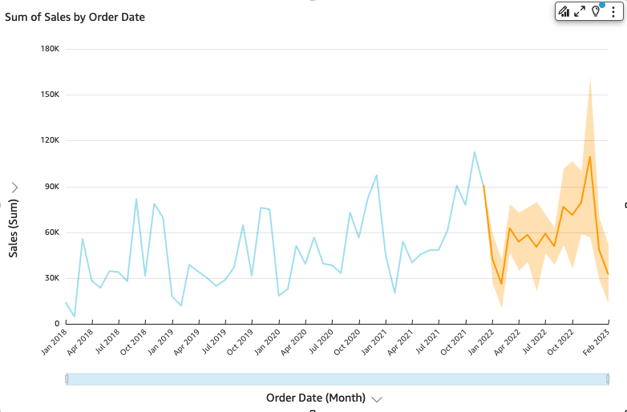

*Image description: The preceding image shows the line graph of sales over time with a forecast visualization*.

CHALLENGE A

You want to test how accurate forecasting is in QuickSight. Can you figure out how to expand the forecast backward to find how closely the actual sales figures and the forecast match?

**Hint:** For help completing this challenge task, see the [**Challenge A solution**](https://us-east-1.durian.bkr.team.aws.training/session/mVdvWNXtyBiojag1fKnunn?locale=en-US&reference=sCm4f4gcixZqMUgXPoUz5y%3A%3A7759f935-0c5f-4c9f-a8d1-ce89471a7323#lab_1_challenge_a).

TASK 2.2 VISUALIZE SALES YEAR OVER YEAR

Create a KPI to track how sales are performing year over year.

1. In the **Visuals** pane, choose the arrow next to **+ ADD**.
2. In the **Visuals** pane, find and choose the **Key Performance Indicator (KPI)** icon.

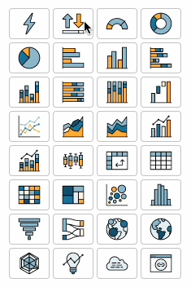

1. In the **Fields list** pane, choose **Sales** and **Order Date**.
2. In the **Visuals** pane, choose the ellipsis icon next to **Order date**.
3. Hover over **Aggregate: Day** and choose **Year** to change the aggregation to year.

**Expected output:** You now have two visualizations: a line graph showing sales by month and a KPI showing sales year over year.

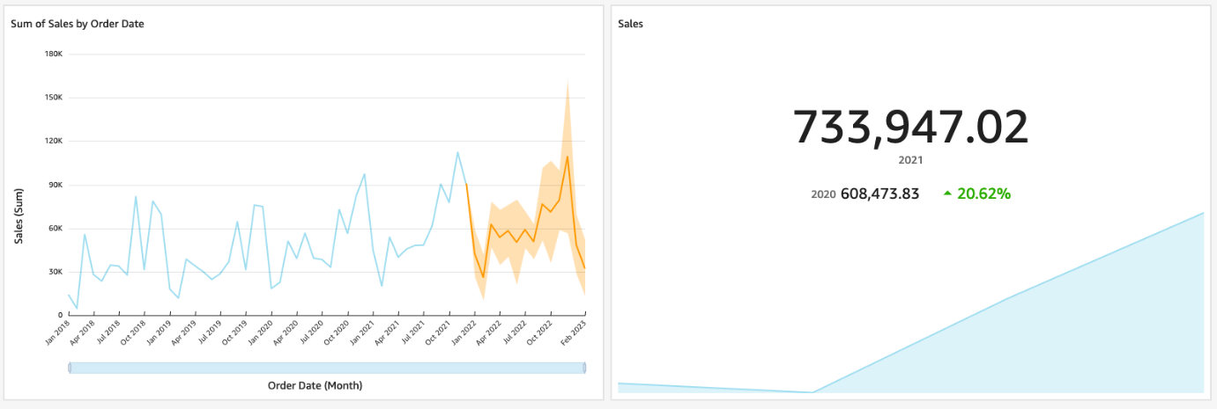

*Image description: The preceding image shows the two visualizations, a line graph and the KPI*.

TASK 2.3: ADD AN AUTOMATED INSIGHT

Add an automated insight to communicate month-over-month trends.

1. Choose one of your visuals.
2. In the navigation pane at the top of the page, choose the **Insights** icon.
3. In the **Suggested insights** pane, hover over **MONTH OVER MONTH CHANGE** and choose the blue **+** icon to **Add insight**.

**Expected output:** You now have a month-over-month, text-based insight on your dashboard.



*Image description: The preceding image shows the text from the new insight*.

**Note:** You can resize the visualization by selecting and dragging any of the white squares at the corners or edges of the visualization.

TASK 2.4: ADD AN AUTOMATED INSIGHT THAT USES FORECASTED DATA

Add an automated insight to communicate the forecasted findings.

1. In the navigation pane at the top of the page, choose the **Insights** icon.
2. In the **Suggested insights** pane, hover over **FORECAST** and choose the blue **+** icon to **Add insight**.

**Expected output:** You now have an automated forecast insight on your dashboard.



*Image description: The preceding image shows the text from the new insight*.

**Consider:** Explore some of the other automated insights in the **Suggested insights** menu. Would any of these insights be helpful in your quarterly business meeting with the board?

* **Task complete:** You have completed **Task 2** by exploring different visual types in QuickSight. You created a forecast, visualized sales year over year with a new KPI, and added two automated insights to your dashboard.

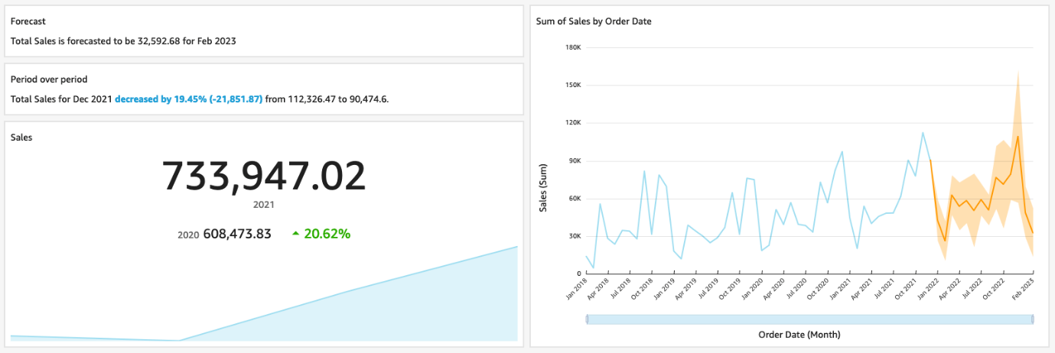

*Image description: The preceding image shows the entire analysis dashboard*.

**Task 3: Drill down into the data**

The board wants to know which customers impacted the energy industry the most. You create a visualization that can answer that question and many of the board’s follow-up questions. During the board meeting, you also want to be able to show aggregated sales numbers by region and subregion.

In this task, you first create a donut chart to visualize sales by industry. Then, you create a second layer of customers so that you can drill down into customers for each industry. After that, you add data labels to clearly identify the results. Finally, you create a pivot table to view sales by region and subregion for each year, and apply custom formatting.

TASK 3.1: VISUALIZE SALES BY INDUSTRY

Create a donut chart to visualize the impact of various industries on sales.

1. In the **Visuals** pane, choose the arrow next to **+ ADD**.
2. Find and choose the **Donut chart** icon.
3. In the **Fields list** pane, choose **Sales** and **Industry**.

 A donut chart appears with sales broken down by industry.

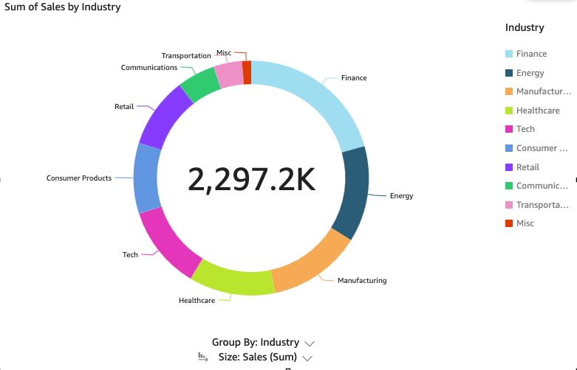

*Image description: The preceding image shows the donut visualization*.

TASK 3.2: ADD A CUSTOMER LAYER TO THE VISUALIZATION

Create a second layer of customers so you can drill down into the customers for each industry as needed.

1. From the **Fields list** pane, drag the **Customer** field to the **Add a dimension** field under **Industry** in the **Visuals** pane, until you see an *Add drill-down layer* pop-up prompt.
2. In the Industry visualization, choose the **Energy** slice of the donut chart.
3. To drill down into the energy customer breakdown, choose **Drill down to Customer**.

**Expected output:** A breakdown of sales by energy customer appears.

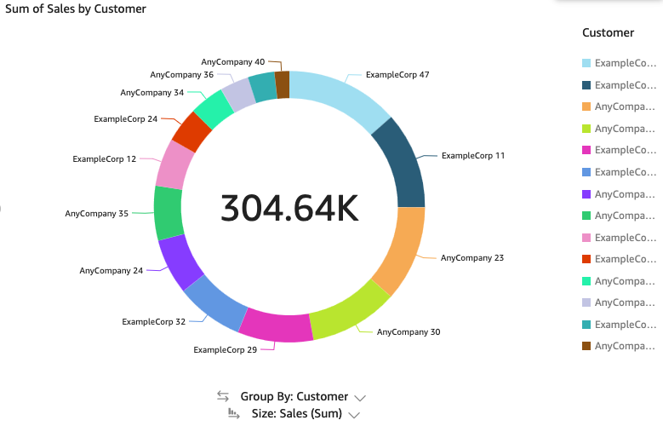

*Image description: The preceding image shows the donut visualization with data showing only energy customers*.

**Consider:** What is the largest customer in the energy industry?

**Note:** If you want to drill back up, choose the **Drill up from Customer** up arrow in the visualization menu to the right of the donut chart.

TASK 3.3: ADD DATA LABELS

Add data labels to the industry visualization so that the results are shown along with the industry and customer data.

1. In the visualization menu on the right of your industry visualization, choose the **Format visual** pencil icon.
2. In the **Properties** pane, choose **Data labels**.
3. Next to **Metric**, choose the eye icon.

**Expected output:** Data labels are added to each industry, showing the total sales over the last three years by industry.

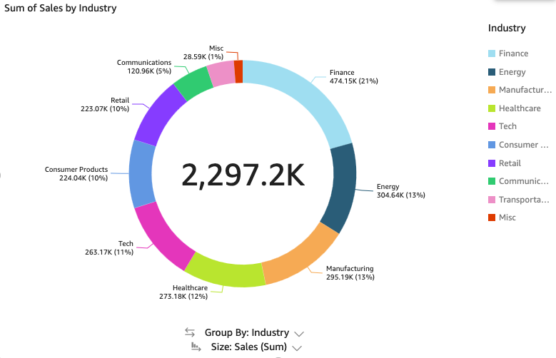

*Image description: The preceding image shows the donut visualization with additional labels*.

TASK 3.4: CREATE A PIVOT TABLE

Create a pivot table to view sales by region and subregion for each year.

1. In the **Visuals** pane, choose the arrow next to **+ ADD**.
2. In the **Visual types** pane, find and choose the **Pivot table** icon.
3. In the **Fields list** pane, choose **Sales**, **Region**, and **Subregion**.
4. To add a dimension, drag **Order Date** to the **Columns** section to add a dimension.
5. Next to **Order Date**, choose the ellipsis icon.
6. Hover over **Aggregate: Day** and choose **Year** to change the aggregation to year.
7. In the pivot table visualization, choose **Rows**, and then choose **Collapse: Region**.

**Expected output:** You now have a pivot table that summarizes all of the sales in each region over the last four years. It can be expanded to include subregions.

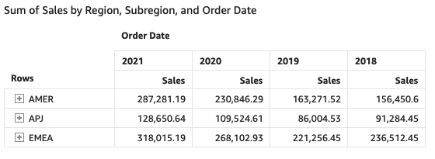

*Image description: The preceding image shows the pivot table*.

TASK 3.5: FORMAT A PIVOT TABLE

Format the pivot table to collapse the subregions, improve the visual flow, and show subtotals of sales.

1. In the visualization menu on the right of your pivot table visualization, choose the **Format visual** pencil icon.
2. In the **Properties** pane, choose **Pivot options**.
3. Next to **Single metric**, choose the eye icon to hide the single metric and remove the repetitive **Sales** headers on each column.
4. In the **Properties** pane, choose **Subtotal**.
5. Verify that **Rows** is turned on.
6. Next to **Background**, select the color square and choose a color from the color options.
7. From the **Apply styling to** dropdown list, choose **Headers only**.

**Expected output:** Now, when you expand a region (and subregion), you see a subtotal. Your visualization is cleaned up and ready to present to the board.

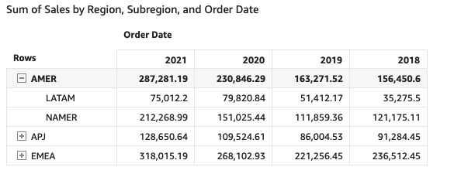

*Image description: The preceding image shows the pivot table with subtotals*.

* **Task complete:** You have completed **Task 3** by drilling down into your data. You created a donut chart to explore the industry field, added another layer to a visualization, added data labels, created a pivot table, and applied custom formatting.

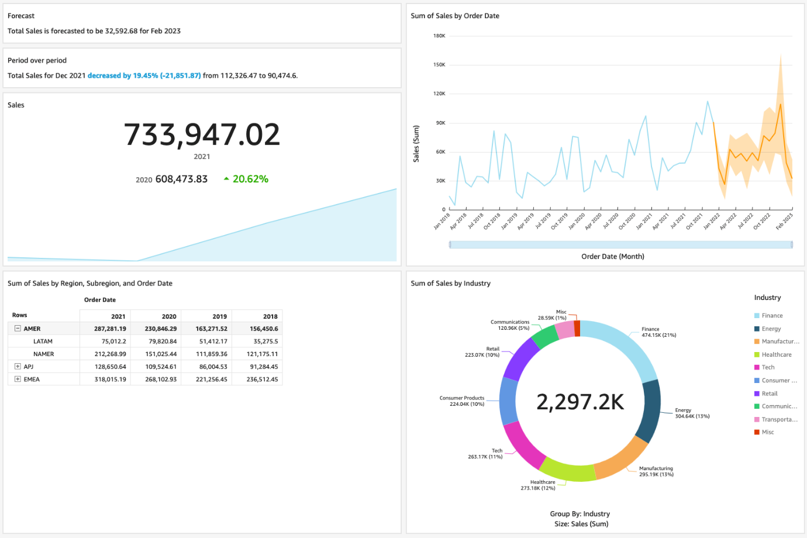

*Image description: The preceding image shows the entire dashboard*.

**Task 4: Filter the data**

During the board meeting, you know that the executives will ask questions that require on-demand filtering of the dashboard. You want to add this functionality.

In this task, you create a filter, apply the filter to all visualizations, and add a filter action to connect visualizations together.

QuickSight offers dynamic filter options for all kinds of visualizations and dashboards. You can adjust the levels of interactivity and connections between visualizations based on your business needs.

TASK 4.1: CREATE A FILTER

Create a filter on your dashboard using the QuickSight filter menu.

1. Choose one of your visuals.
2. In the navigation pane at the top of the page, choose the **Filter** icon.
3. In the **Filters** pane, choose **+ ADD**.
4. From the list, choose **Segment**.
5. In the **Filters** column, choose **Segment** to expand the filter options.

**Note:** By default, QuickSight applies a new filter only on the visual selected when you created the filter. If you want a filter to apply to all visuals, adjust the filter settings to **All applicable visuals**.

1. Under **Applied to**, choose **Only this visual**, and then choose **All applicable visuals** to filter all of the visualizations on your dashboard at the same time.
2. Next to the **Segment** filter, choose the ellipsis icon and then choose **Add to sheet**.

**Expected output:** Your dashboard now displays your filter. If you choose an item in the filter, all of the applicable visuals filter to the segment you choose.

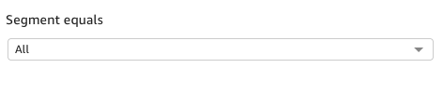

*Image description: The preceding image shows the updated pivot table*.

TASK 4.2: ADD A FILTER ACTION

Add a filter action to connect visualizations together so that everything updates simultaneously. QuickSight filter actions adjust dashboard calculations dynamically in the other visualizations based on your selections.

1. Choose the Industry donut chart visualization.
2. In the visualization menu to the right of your donut chart visualization, choose the **Menu options** ellipsis icon and choose **Actions**.
3. To create a filter action that filters all visuals based on selections made in the industry donut chart, in the **Actions** pane, in the **Quick create** section, choose **Filter same-sheet visuals**.

**Expected output:** If you choose any slice in the industry donut chart, everything on the dashboard now filters to that industry.

**Note:** To remove the filter for that industry, choose anywhere within the donut chart visualization.

CHALLENGE B

Before you move on to the board meeting, you want to organize the visualizations, filters, and insights on your dashboard. Take some time to move the visuals around until you are satisfied with the final layout. Consider how you want to present the sales story to the board members.

**Hint:** For help completing this challenge task, see the [**Challenge B solution**](https://us-east-1.durian.bkr.team.aws.training/session/mVdvWNXtyBiojag1fKnunn?locale=en-US&reference=sCm4f4gcixZqMUgXPoUz5y%3A%3A7759f935-0c5f-4c9f-a8d1-ce89471a7323#lab_1_challenge_b).

* **Task complete:** You have completed **Task 4** by filtering your data. You created a filter and added a custom filter action to your dashboard.

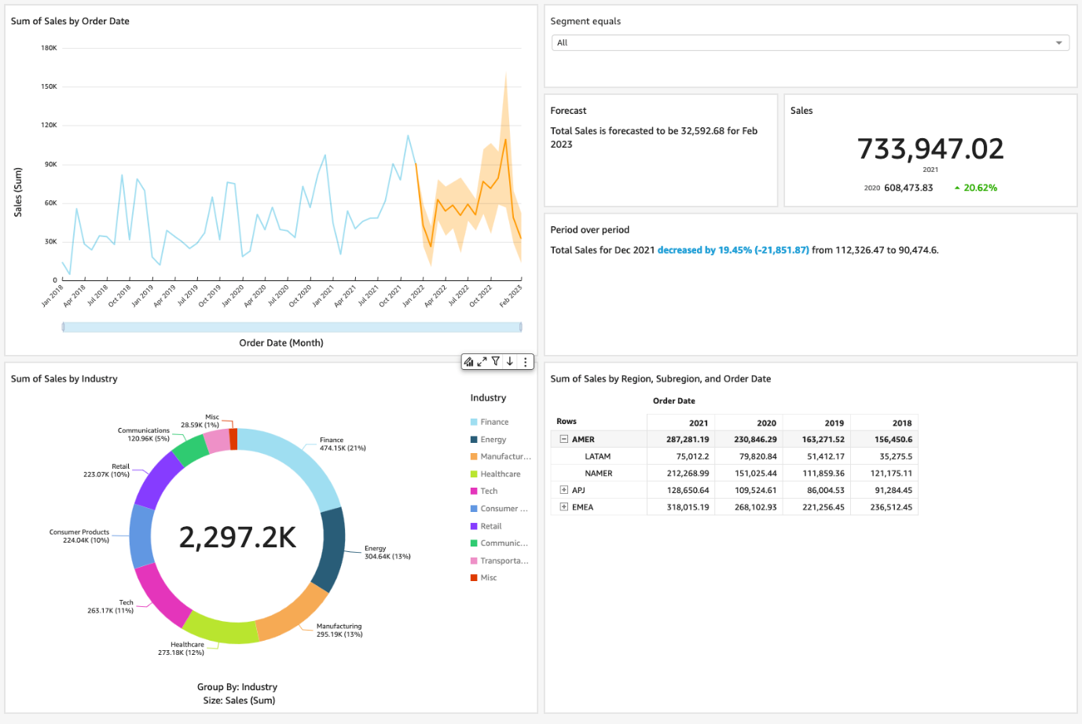

*Image description: The preceding image shows the entire dashboard*.

**Task 5: Share reports**

Now that you have organized all of the visuals, you are ready for the board meeting. You want to use the sharing capabilities of QuickSight to publish the analysis as a dashboard.

In this task, you publish a QuickSight dashboard. QuickSight has built-in automatic dashboard sharing capabilities, so you can schedule reports based on your organization’s reporting needs.

TASK 5.1: ADD A TITLE

Add a title to your dashboard.

1. In the top menu bar, choose **Sheets**.
2. Choose **Add Title**.
3. At the top of the dashboard workspace, in the **Sheet title** section, enter

.

**Note:** If you want to rename a visualization title, you can choose the current visualization title, and then enter a new title.

**Expected output:** You now have a title for your dashboard.

TASK 5.2: PUBLISH A DASHBOARD

Publish a dashboard so you can share it to your team.

1. In the top menu bar, on the right side, choose the **PUBLISH** icon.
2. For **Publish new dashboard as**, enter

.

1. Choose **Publish dashboard**.

**Expected output:** You are automatically redirected to your dashboard. Take a moment to explore the work you just completed.

**Learn more:** A dashboard is a read-only snapshot of an analysis that you can share with other Amazon QuickSight users for reporting purposes. For more information about dashboard sharing capabilities, including automated dashboard reporting, see [Sharing and subscribing to data in Amazon QuickSight](https://docs.aws.amazon.com/quicksight/latest/user/working-with-dashboards.html) in the *Amazon QuickSight User Guide*.

* **Task complete:** You have completed **Task 5** by publishing your dashboard. You added a title, published your dashboard, and viewed the dashboard.

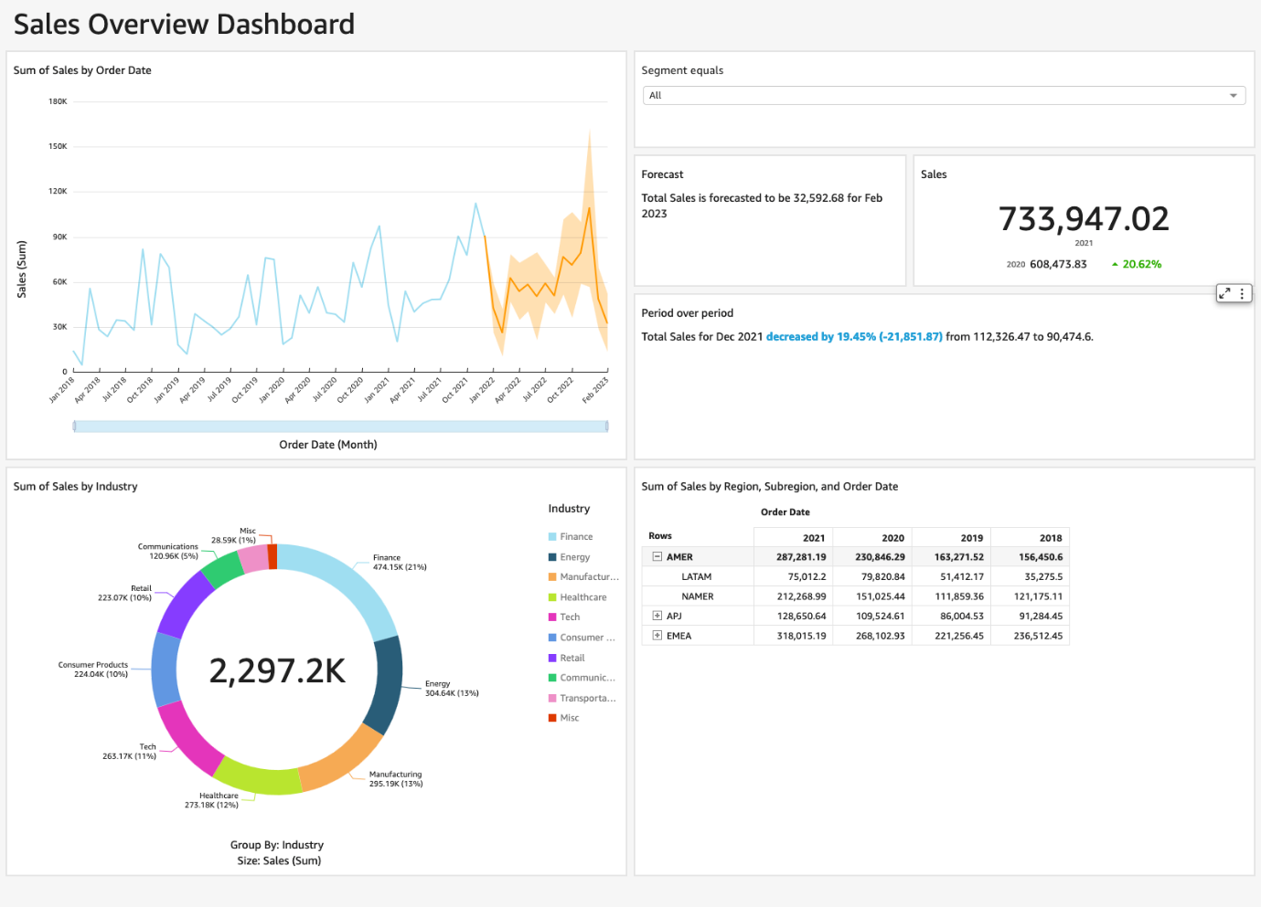

*Image description: The preceding image shows the entire dashboard*.

**Conclusion**

**Task complete:** The AnyCompany Software board is excited about the sales figures. The board is even more excited about the big data reporting, processing power, visual flow, and automated sharing capabilities of Amazon QuickSight.

You have successfully done the following:

* Loaded a dataset into Amazon QuickSight
* Created a QuickSight dashboard
* Customized a QuickSight dashboard to visualize data and extract business insights
* Configured appropriate visualization types to identify trends in the data

**End lab**

Follow these steps to close out the console and end your lab.

1. At the upper-right corner of the QuickSight console, choose the user icon and then choose **Sign out**.
2. On this screen, choose **End lab** and then confirm that you want to end your lab.

**Appendix**

CHALLENGE A SOLUTION

**Answer:** To complete this challenge, forecast backwards using the **Periods backward** option in the **Forecast properties** menu.

1. Choose the sales visualization.
2. In the navigation pane at the left of the page, under **Forecast properties**, change **Periods backward** to

.

1. Choose **APPLY**.

A line of best fit (in orange) is shown on top of an actual sales line (in blue). The closer the orange line is to the blue line, the better the future prediction. QuickSight offers this functionality so that you can prove out the predictive model before presenting its insights.

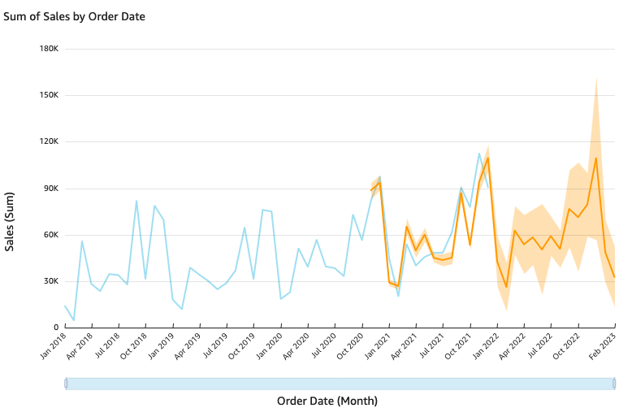

*Image description: The preceding image shows the line graph with a backwards forecast*.

To continue this lab, move on to [Task 2.2](https://us-east-1.durian.bkr.team.aws.training/session/mVdvWNXtyBiojag1fKnunn?locale=en-US&reference=sCm4f4gcixZqMUgXPoUz5y%3A%3A7759f935-0c5f-4c9f-a8d1-ce89471a7323#lab_1_task2-continue).

CHALLENGE B SOLUTION

**Answer:** To complete this challenge, move the visuals around and resize them to make good use of your dashboard space. Organize your visuals based on how you think your readers would want to view the dashboard.

**Note:** Optimal dashboard design has many theories. A leading theory places the most important visual on the top left, with KPIs and filters on the top right. On the bottom left, the industry donut chart pairs nicely with the pivot table on the right, solidifying the dashboard structure with a firm base.

Your reader can spend time digging into the industry data and subregion data for further analysis. QuickSight dynamically adjusts the other visualizations with the filter action you set up on the industry visualization.

Here is a sample of what an organized dashboard can look like:



*Image description: The preceding image shows the entire dashboard*.

To continue this lab, move on to [Task 5](https://us-east-1.durian.bkr.team.aws.training/session/mVdvWNXtyBiojag1fKnunn?locale=en-US&reference=sCm4f4gcixZqMUgXPoUz5y%3A%3A7759f935-0c5f-4c9f-a8d1-ce89471a7323#lab_1_task5-continue).